Mpg (Miles per gallon) dataset

#Load libraries  
library (readr)  
library(dplyr)

##   
## Attaching package: 'dplyr'

## The following objects are masked from 'package:stats':  
##   
## filter, lag

## The following objects are masked from 'package:base':  
##   
## intersect, setdiff, setequal, union

library(lattice)  
#Loading df object  
df <- read_csv("mpg dataset.csv", col_types = cols(horsepower = col_integer()))  
print(df)

## # A tibble: 398 × 9  
## mpg cylinders displacement horsepower weight accel…¹ model…² origin car_n…³  
## <dbl> <dbl> <dbl> <int> <dbl> <dbl> <dbl> <dbl> <chr>   
## 1 18 8 307 130 3504 12 70 1 chevro…  
## 2 15 8 350 165 3693 11.5 70 1 buick …  
## 3 18 8 318 150 3436 11 70 1 plymou…  
## 4 16 8 304 150 3433 12 70 1 amc re…  
## 5 17 8 302 140 3449 10.5 70 1 ford t…  
## 6 15 8 429 198 4341 10 70 1 ford g…  
## 7 14 8 454 220 4354 9 70 1 chevro…  
## 8 14 8 440 215 4312 8.5 70 1 plymou…  
## 9 14 8 455 225 4425 10 70 1 pontia…  
## 10 15 8 390 190 3850 8.5 70 1 amc am…  
## # … with 388 more rows, and abbreviated variable names ¹​acceleration,  
## # ²​model_year, ³​car_name

df

## mpg cylinders displacement horsepower weight acceleration model_year  
## 1 18.0 8 307.0 130 3504 12.0 70  
## 2 15.0 8 350.0 165 3693 11.5 70  
## 3 18.0 8 318.0 150 3436 11.0 70  
## 4 16.0 8 304.0 150 3433 12.0 70  
## 5 17.0 8 302.0 140 3449 10.5 70  
## 6 15.0 8 429.0 198 4341 10.0 70  
## 7 14.0 8 454.0 220 4354 9.0 70  
## 8 14.0 8 440.0 215 4312 8.5 70  
## 9 14.0 8 455.0 225 4425 10.0 70  
## 10 15.0 8 390.0 190 3850 8.5 70  
## 11 15.0 8 383.0 170 3563 10.0 70  
## 12 14.0 8 340.0 160 3609 8.0 70  
## 13 15.0 8 400.0 150 3761 9.5 70  
## 14 14.0 8 455.0 225 3086 10.0 70  
## 15 24.0 4 113.0 95 2372 15.0 70  
## 16 22.0 6 198.0 95 2833 15.5 70  
## 17 18.0 6 199.0 97 2774 15.5 70  
## 18 21.0 6 200.0 85 2587 16.0 70  
## 19 27.0 4 97.0 88 2130 14.5 70  
## 20 26.0 4 97.0 46 1835 20.5 70  
## 21 25.0 4 110.0 87 2672 17.5 70  
## 22 24.0 4 107.0 90 2430 14.5 70  
## 23 25.0 4 104.0 95 2375 17.5 70  
## 24 26.0 4 121.0 113 2234 12.5 70  
## 25 21.0 6 199.0 90 2648 15.0 70  
## 26 10.0 8 360.0 215 4615 14.0 70  
## 27 10.0 8 307.0 200 4376 15.0 70  
## 28 11.0 8 318.0 210 4382 13.5 70  
## 29 9.0 8 304.0 193 4732 18.5 70  
## 30 27.0 4 97.0 88 2130 14.5 71  
## 31 28.0 4 140.0 90 2264 15.5 71  
## 32 25.0 4 113.0 95 2228 14.0 71  
## 33 25.0 4 98.0 ? 2046 19.0 71  
## 34 19.0 6 232.0 100 2634 13.0 71  
## 35 16.0 6 225.0 105 3439 15.5 71  
## 36 17.0 6 250.0 100 3329 15.5 71  
## 37 19.0 6 250.0 88 3302 15.5 71  
## 38 18.0 6 232.0 100 3288 15.5 71  
## 39 14.0 8 350.0 165 4209 12.0 71  
## 40 14.0 8 400.0 175 4464 11.5 71  
## 41 14.0 8 351.0 153 4154 13.5 71  
## 42 14.0 8 318.0 150 4096 13.0 71  
## 43 12.0 8 383.0 180 4955 11.5 71  
## 44 13.0 8 400.0 170 4746 12.0 71  
## 45 13.0 8 400.0 175 5140 12.0 71  
## 46 18.0 6 258.0 110 2962 13.5 71  
## 47 22.0 4 140.0 72 2408 19.0 71  
## 48 19.0 6 250.0 100 3282 15.0 71  
## 49 18.0 6 250.0 88 3139 14.5 71  
## 50 23.0 4 122.0 86 2220 14.0 71  
## 51 28.0 4 116.0 90 2123 14.0 71  
## 52 30.0 4 79.0 70 2074 19.5 71  
## 53 30.0 4 88.0 76 2065 14.5 71  
## 54 31.0 4 71.0 65 1773 19.0 71  
## 55 35.0 4 72.0 69 1613 18.0 71  
## 56 27.0 4 97.0 60 1834 19.0 71  
## 57 26.0 4 91.0 70 1955 20.5 71  
## 58 24.0 4 113.0 95 2278 15.5 72  
## 59 25.0 4 97.5 80 2126 17.0 72  
## 60 23.0 4 97.0 54 2254 23.5 72  
## 61 20.0 4 140.0 90 2408 19.5 72  
## 62 21.0 4 122.0 86 2226 16.5 72  
## 63 13.0 8 350.0 165 4274 12.0 72  
## 64 14.0 8 400.0 175 4385 12.0 72  
## 65 15.0 8 318.0 150 4135 13.5 72  
## 66 14.0 8 351.0 153 4129 13.0 72  
## 67 17.0 8 304.0 150 3672 11.5 72  
## 68 11.0 8 429.0 208 4633 11.0 72  
## 69 13.0 8 350.0 155 4502 13.5 72  
## 70 12.0 8 350.0 160 4456 13.5 72  
## 71 13.0 8 400.0 190 4422 12.5 72  
## 72 19.0 3 70.0 97 2330 13.5 72  
## 73 15.0 8 304.0 150 3892 12.5 72  
## 74 13.0 8 307.0 130 4098 14.0 72  
## 75 13.0 8 302.0 140 4294 16.0 72  
## 76 14.0 8 318.0 150 4077 14.0 72  
## 77 18.0 4 121.0 112 2933 14.5 72  
## 78 22.0 4 121.0 76 2511 18.0 72  
## 79 21.0 4 120.0 87 2979 19.5 72  
## 80 26.0 4 96.0 69 2189 18.0 72  
## 81 22.0 4 122.0 86 2395 16.0 72  
## 82 28.0 4 97.0 92 2288 17.0 72  
## 83 23.0 4 120.0 97 2506 14.5 72  
## 84 28.0 4 98.0 80 2164 15.0 72  
## 85 27.0 4 97.0 88 2100 16.5 72  
## 86 13.0 8 350.0 175 4100 13.0 73  
## 87 14.0 8 304.0 150 3672 11.5 73  
## 88 13.0 8 350.0 145 3988 13.0 73  
## 89 14.0 8 302.0 137 4042 14.5 73  
## 90 15.0 8 318.0 150 3777 12.5 73  
## 91 12.0 8 429.0 198 4952 11.5 73  
## 92 13.0 8 400.0 150 4464 12.0 73  
## 93 13.0 8 351.0 158 4363 13.0 73  
## 94 14.0 8 318.0 150 4237 14.5 73  
## 95 13.0 8 440.0 215 4735 11.0 73  
## 96 12.0 8 455.0 225 4951 11.0 73  
## 97 13.0 8 360.0 175 3821 11.0 73  
## 98 18.0 6 225.0 105 3121 16.5 73  
## 99 16.0 6 250.0 100 3278 18.0 73  
## 100 18.0 6 232.0 100 2945 16.0 73  
## 101 18.0 6 250.0 88 3021 16.5 73  
## 102 23.0 6 198.0 95 2904 16.0 73  
## 103 26.0 4 97.0 46 1950 21.0 73  
## 104 11.0 8 400.0 150 4997 14.0 73  
## 105 12.0 8 400.0 167 4906 12.5 73  
## 106 13.0 8 360.0 170 4654 13.0 73  
## 107 12.0 8 350.0 180 4499 12.5 73  
## 108 18.0 6 232.0 100 2789 15.0 73  
## 109 20.0 4 97.0 88 2279 19.0 73  
## 110 21.0 4 140.0 72 2401 19.5 73  
## 111 22.0 4 108.0 94 2379 16.5 73  
## 112 18.0 3 70.0 90 2124 13.5 73  
## 113 19.0 4 122.0 85 2310 18.5 73  
## 114 21.0 6 155.0 107 2472 14.0 73  
## 115 26.0 4 98.0 90 2265 15.5 73  
## 116 15.0 8 350.0 145 4082 13.0 73  
## 117 16.0 8 400.0 230 4278 9.5 73  
## 118 29.0 4 68.0 49 1867 19.5 73  
## 119 24.0 4 116.0 75 2158 15.5 73  
## 120 20.0 4 114.0 91 2582 14.0 73  
## 121 19.0 4 121.0 112 2868 15.5 73  
## 122 15.0 8 318.0 150 3399 11.0 73  
## 123 24.0 4 121.0 110 2660 14.0 73  
## 124 20.0 6 156.0 122 2807 13.5 73  
## 125 11.0 8 350.0 180 3664 11.0 73  
## 126 20.0 6 198.0 95 3102 16.5 74  
## 127 21.0 6 200.0 ? 2875 17.0 74  
## 128 19.0 6 232.0 100 2901 16.0 74  
## 129 15.0 6 250.0 100 3336 17.0 74  
## 130 31.0 4 79.0 67 1950 19.0 74  
## 131 26.0 4 122.0 80 2451 16.5 74  
## 132 32.0 4 71.0 65 1836 21.0 74  
## 133 25.0 4 140.0 75 2542 17.0 74  
## 134 16.0 6 250.0 100 3781 17.0 74  
## 135 16.0 6 258.0 110 3632 18.0 74  
## 136 18.0 6 225.0 105 3613 16.5 74  
## 137 16.0 8 302.0 140 4141 14.0 74  
## 138 13.0 8 350.0 150 4699 14.5 74  
## 139 14.0 8 318.0 150 4457 13.5 74  
## 140 14.0 8 302.0 140 4638 16.0 74  
## 141 14.0 8 304.0 150 4257 15.5 74  
## 142 29.0 4 98.0 83 2219 16.5 74  
## 143 26.0 4 79.0 67 1963 15.5 74  
## 144 26.0 4 97.0 78 2300 14.5 74  
## 145 31.0 4 76.0 52 1649 16.5 74  
## 146 32.0 4 83.0 61 2003 19.0 74  
## 147 28.0 4 90.0 75 2125 14.5 74  
## 148 24.0 4 90.0 75 2108 15.5 74  
## 149 26.0 4 116.0 75 2246 14.0 74  
## 150 24.0 4 120.0 97 2489 15.0 74  
## 151 26.0 4 108.0 93 2391 15.5 74  
## 152 31.0 4 79.0 67 2000 16.0 74  
## 153 19.0 6 225.0 95 3264 16.0 75  
## 154 18.0 6 250.0 105 3459 16.0 75  
## 155 15.0 6 250.0 72 3432 21.0 75  
## 156 15.0 6 250.0 72 3158 19.5 75  
## 157 16.0 8 400.0 170 4668 11.5 75  
## 158 15.0 8 350.0 145 4440 14.0 75  
## 159 16.0 8 318.0 150 4498 14.5 75  
## 160 14.0 8 351.0 148 4657 13.5 75  
## 161 17.0 6 231.0 110 3907 21.0 75  
## 162 16.0 6 250.0 105 3897 18.5 75  
## 163 15.0 6 258.0 110 3730 19.0 75  
## 164 18.0 6 225.0 95 3785 19.0 75  
## 165 21.0 6 231.0 110 3039 15.0 75  
## 166 20.0 8 262.0 110 3221 13.5 75  
## 167 13.0 8 302.0 129 3169 12.0 75  
## 168 29.0 4 97.0 75 2171 16.0 75  
## 169 23.0 4 140.0 83 2639 17.0 75  
## 170 20.0 6 232.0 100 2914 16.0 75  
## 171 23.0 4 140.0 78 2592 18.5 75  
## 172 24.0 4 134.0 96 2702 13.5 75  
## 173 25.0 4 90.0 71 2223 16.5 75  
## 174 24.0 4 119.0 97 2545 17.0 75  
## 175 18.0 6 171.0 97 2984 14.5 75  
## 176 29.0 4 90.0 70 1937 14.0 75  
## 177 19.0 6 232.0 90 3211 17.0 75  
## 178 23.0 4 115.0 95 2694 15.0 75  
## 179 23.0 4 120.0 88 2957 17.0 75  
## 180 22.0 4 121.0 98 2945 14.5 75  
## 181 25.0 4 121.0 115 2671 13.5 75  
## 182 33.0 4 91.0 53 1795 17.5 75  
## 183 28.0 4 107.0 86 2464 15.5 76  
## 184 25.0 4 116.0 81 2220 16.9 76  
## 185 25.0 4 140.0 92 2572 14.9 76  
## 186 26.0 4 98.0 79 2255 17.7 76  
## 187 27.0 4 101.0 83 2202 15.3 76  
## 188 17.5 8 305.0 140 4215 13.0 76  
## 189 16.0 8 318.0 150 4190 13.0 76  
## 190 15.5 8 304.0 120 3962 13.9 76  
## 191 14.5 8 351.0 152 4215 12.8 76  
## 192 22.0 6 225.0 100 3233 15.4 76  
## 193 22.0 6 250.0 105 3353 14.5 76  
## 194 24.0 6 200.0 81 3012 17.6 76  
## 195 22.5 6 232.0 90 3085 17.6 76  
## 196 29.0 4 85.0 52 2035 22.2 76  
## 197 24.5 4 98.0 60 2164 22.1 76  
## 198 29.0 4 90.0 70 1937 14.2 76  
## 199 33.0 4 91.0 53 1795 17.4 76  
## 200 20.0 6 225.0 100 3651 17.7 76  
## 201 18.0 6 250.0 78 3574 21.0 76  
## 202 18.5 6 250.0 110 3645 16.2 76  
## 203 17.5 6 258.0 95 3193 17.8 76  
## 204 29.5 4 97.0 71 1825 12.2 76  
## 205 32.0 4 85.0 70 1990 17.0 76  
## 206 28.0 4 97.0 75 2155 16.4 76  
## 207 26.5 4 140.0 72 2565 13.6 76  
## 208 20.0 4 130.0 102 3150 15.7 76  
## 209 13.0 8 318.0 150 3940 13.2 76  
## 210 19.0 4 120.0 88 3270 21.9 76  
## 211 19.0 6 156.0 108 2930 15.5 76  
## 212 16.5 6 168.0 120 3820 16.7 76  
## 213 16.5 8 350.0 180 4380 12.1 76  
## 214 13.0 8 350.0 145 4055 12.0 76  
## 215 13.0 8 302.0 130 3870 15.0 76  
## 216 13.0 8 318.0 150 3755 14.0 76  
## 217 31.5 4 98.0 68 2045 18.5 77  
## 218 30.0 4 111.0 80 2155 14.8 77  
## 219 36.0 4 79.0 58 1825 18.6 77  
## 220 25.5 4 122.0 96 2300 15.5 77  
## 221 33.5 4 85.0 70 1945 16.8 77  
## 222 17.5 8 305.0 145 3880 12.5 77  
## 223 17.0 8 260.0 110 4060 19.0 77  
## 224 15.5 8 318.0 145 4140 13.7 77  
## 225 15.0 8 302.0 130 4295 14.9 77  
## 226 17.5 6 250.0 110 3520 16.4 77  
## 227 20.5 6 231.0 105 3425 16.9 77  
## 228 19.0 6 225.0 100 3630 17.7 77  
## 229 18.5 6 250.0 98 3525 19.0 77  
## 230 16.0 8 400.0 180 4220 11.1 77  
## 231 15.5 8 350.0 170 4165 11.4 77  
## 232 15.5 8 400.0 190 4325 12.2 77  
## 233 16.0 8 351.0 149 4335 14.5 77  
## 234 29.0 4 97.0 78 1940 14.5 77  
## 235 24.5 4 151.0 88 2740 16.0 77  
## 236 26.0 4 97.0 75 2265 18.2 77  
## 237 25.5 4 140.0 89 2755 15.8 77  
## 238 30.5 4 98.0 63 2051 17.0 77  
## 239 33.5 4 98.0 83 2075 15.9 77  
## 240 30.0 4 97.0 67 1985 16.4 77  
## 241 30.5 4 97.0 78 2190 14.1 77  
## 242 22.0 6 146.0 97 2815 14.5 77  
## 243 21.5 4 121.0 110 2600 12.8 77  
## 244 21.5 3 80.0 110 2720 13.5 77  
## 245 43.1 4 90.0 48 1985 21.5 78  
## 246 36.1 4 98.0 66 1800 14.4 78  
## 247 32.8 4 78.0 52 1985 19.4 78  
## 248 39.4 4 85.0 70 2070 18.6 78  
## 249 36.1 4 91.0 60 1800 16.4 78  
## 250 19.9 8 260.0 110 3365 15.5 78  
## 251 19.4 8 318.0 140 3735 13.2 78  
## 252 20.2 8 302.0 139 3570 12.8 78  
## 253 19.2 6 231.0 105 3535 19.2 78  
## 254 20.5 6 200.0 95 3155 18.2 78  
## 255 20.2 6 200.0 85 2965 15.8 78  
## 256 25.1 4 140.0 88 2720 15.4 78  
## 257 20.5 6 225.0 100 3430 17.2 78  
## 258 19.4 6 232.0 90 3210 17.2 78  
## 259 20.6 6 231.0 105 3380 15.8 78  
## 260 20.8 6 200.0 85 3070 16.7 78  
## 261 18.6 6 225.0 110 3620 18.7 78  
## 262 18.1 6 258.0 120 3410 15.1 78  
## 263 19.2 8 305.0 145 3425 13.2 78  
## 264 17.7 6 231.0 165 3445 13.4 78  
## 265 18.1 8 302.0 139 3205 11.2 78  
## 266 17.5 8 318.0 140 4080 13.7 78  
## 267 30.0 4 98.0 68 2155 16.5 78  
## 268 27.5 4 134.0 95 2560 14.2 78  
## 269 27.2 4 119.0 97 2300 14.7 78  
## 270 30.9 4 105.0 75 2230 14.5 78  
## 271 21.1 4 134.0 95 2515 14.8 78  
## 272 23.2 4 156.0 105 2745 16.7 78  
## 273 23.8 4 151.0 85 2855 17.6 78  
## 274 23.9 4 119.0 97 2405 14.9 78  
## 275 20.3 5 131.0 103 2830 15.9 78  
## 276 17.0 6 163.0 125 3140 13.6 78  
## 277 21.6 4 121.0 115 2795 15.7 78  
## 278 16.2 6 163.0 133 3410 15.8 78  
## 279 31.5 4 89.0 71 1990 14.9 78  
## 280 29.5 4 98.0 68 2135 16.6 78  
## 281 21.5 6 231.0 115 3245 15.4 79  
## 282 19.8 6 200.0 85 2990 18.2 79  
## 283 22.3 4 140.0 88 2890 17.3 79  
## 284 20.2 6 232.0 90 3265 18.2 79  
## 285 20.6 6 225.0 110 3360 16.6 79  
## 286 17.0 8 305.0 130 3840 15.4 79  
## 287 17.6 8 302.0 129 3725 13.4 79  
## 288 16.5 8 351.0 138 3955 13.2 79  
## 289 18.2 8 318.0 135 3830 15.2 79  
## 290 16.9 8 350.0 155 4360 14.9 79  
## 291 15.5 8 351.0 142 4054 14.3 79  
## 292 19.2 8 267.0 125 3605 15.0 79  
## 293 18.5 8 360.0 150 3940 13.0 79  
## 294 31.9 4 89.0 71 1925 14.0 79  
## 295 34.1 4 86.0 65 1975 15.2 79  
## 296 35.7 4 98.0 80 1915 14.4 79  
## 297 27.4 4 121.0 80 2670 15.0 79  
## 298 25.4 5 183.0 77 3530 20.1 79  
## 299 23.0 8 350.0 125 3900 17.4 79  
## 300 27.2 4 141.0 71 3190 24.8 79  
## 301 23.9 8 260.0 90 3420 22.2 79  
## 302 34.2 4 105.0 70 2200 13.2 79  
## 303 34.5 4 105.0 70 2150 14.9 79  
## 304 31.8 4 85.0 65 2020 19.2 79  
## 305 37.3 4 91.0 69 2130 14.7 79  
## 306 28.4 4 151.0 90 2670 16.0 79  
## 307 28.8 6 173.0 115 2595 11.3 79  
## 308 26.8 6 173.0 115 2700 12.9 79  
## 309 33.5 4 151.0 90 2556 13.2 79  
## 310 41.5 4 98.0 76 2144 14.7 80  
## 311 38.1 4 89.0 60 1968 18.8 80  
## 312 32.1 4 98.0 70 2120 15.5 80  
## 313 37.2 4 86.0 65 2019 16.4 80  
## 314 28.0 4 151.0 90 2678 16.5 80  
## 315 26.4 4 140.0 88 2870 18.1 80  
## 316 24.3 4 151.0 90 3003 20.1 80  
## 317 19.1 6 225.0 90 3381 18.7 80  
## 318 34.3 4 97.0 78 2188 15.8 80  
## 319 29.8 4 134.0 90 2711 15.5 80  
## 320 31.3 4 120.0 75 2542 17.5 80  
## 321 37.0 4 119.0 92 2434 15.0 80  
## 322 32.2 4 108.0 75 2265 15.2 80  
## 323 46.6 4 86.0 65 2110 17.9 80  
## 324 27.9 4 156.0 105 2800 14.4 80  
## 325 40.8 4 85.0 65 2110 19.2 80  
## 326 44.3 4 90.0 48 2085 21.7 80  
## 327 43.4 4 90.0 48 2335 23.7 80  
## 328 36.4 5 121.0 67 2950 19.9 80  
## 329 30.0 4 146.0 67 3250 21.8 80  
## 330 44.6 4 91.0 67 1850 13.8 80  
## 331 40.9 4 85.0 ? 1835 17.3 80  
## 332 33.8 4 97.0 67 2145 18.0 80  
## 333 29.8 4 89.0 62 1845 15.3 80  
## 334 32.7 6 168.0 132 2910 11.4 80  
## 335 23.7 3 70.0 100 2420 12.5 80  
## 336 35.0 4 122.0 88 2500 15.1 80  
## 337 23.6 4 140.0 ? 2905 14.3 80  
## 338 32.4 4 107.0 72 2290 17.0 80  
## 339 27.2 4 135.0 84 2490 15.7 81  
## 340 26.6 4 151.0 84 2635 16.4 81  
## 341 25.8 4 156.0 92 2620 14.4 81  
## 342 23.5 6 173.0 110 2725 12.6 81  
## 343 30.0 4 135.0 84 2385 12.9 81  
## 344 39.1 4 79.0 58 1755 16.9 81  
## 345 39.0 4 86.0 64 1875 16.4 81  
## 346 35.1 4 81.0 60 1760 16.1 81  
## 347 32.3 4 97.0 67 2065 17.8 81  
## 348 37.0 4 85.0 65 1975 19.4 81  
## 349 37.7 4 89.0 62 2050 17.3 81  
## 350 34.1 4 91.0 68 1985 16.0 81  
## 351 34.7 4 105.0 63 2215 14.9 81  
## 352 34.4 4 98.0 65 2045 16.2 81  
## 353 29.9 4 98.0 65 2380 20.7 81  
## 354 33.0 4 105.0 74 2190 14.2 81  
## 355 34.5 4 100.0 ? 2320 15.8 81  
## 356 33.7 4 107.0 75 2210 14.4 81  
## 357 32.4 4 108.0 75 2350 16.8 81  
## 358 32.9 4 119.0 100 2615 14.8 81  
## 359 31.6 4 120.0 74 2635 18.3 81  
## 360 28.1 4 141.0 80 3230 20.4 81  
## 361 30.7 6 145.0 76 3160 19.6 81  
## 362 25.4 6 168.0 116 2900 12.6 81  
## 363 24.2 6 146.0 120 2930 13.8 81  
## 364 22.4 6 231.0 110 3415 15.8 81  
## 365 26.6 8 350.0 105 3725 19.0 81  
## 366 20.2 6 200.0 88 3060 17.1 81  
## 367 17.6 6 225.0 85 3465 16.6 81  
## 368 28.0 4 112.0 88 2605 19.6 82  
## 369 27.0 4 112.0 88 2640 18.6 82  
## 370 34.0 4 112.0 88 2395 18.0 82  
## 371 31.0 4 112.0 85 2575 16.2 82  
## 372 29.0 4 135.0 84 2525 16.0 82  
## 373 27.0 4 151.0 90 2735 18.0 82  
## 374 24.0 4 140.0 92 2865 16.4 82  
## 375 23.0 4 151.0 ? 3035 20.5 82  
## 376 36.0 4 105.0 74 1980 15.3 82  
## 377 37.0 4 91.0 68 2025 18.2 82  
## 378 31.0 4 91.0 68 1970 17.6 82  
## 379 38.0 4 105.0 63 2125 14.7 82  
## 380 36.0 4 98.0 70 2125 17.3 82  
## 381 36.0 4 120.0 88 2160 14.5 82  
## 382 36.0 4 107.0 75 2205 14.5 82  
## 383 34.0 4 108.0 70 2245 16.9 82  
## 384 38.0 4 91.0 67 1965 15.0 82  
## 385 32.0 4 91.0 67 1965 15.7 82  
## 386 38.0 4 91.0 67 1995 16.2 82  
## 387 25.0 6 181.0 110 2945 16.4 82  
## 388 38.0 6 262.0 85 3015 17.0 82  
## 389 26.0 4 156.0 92 2585 14.5 82  
## 390 22.0 6 232.0 112 2835 14.7 82  
## 391 32.0 4 144.0 96 2665 13.9 82  
## 392 36.0 4 135.0 84 2370 13.0 82  
## 393 27.0 4 151.0 90 2950 17.3 82  
## 394 27.0 4 140.0 86 2790 15.6 82  
## 395 44.0 4 97.0 52 2130 24.6 82  
## 396 32.0 4 135.0 84 2295 11.6 82  
## 397 28.0 4 120.0 79 2625 18.6 82  
## 398 31.0 4 119.0 82 2720 19.4 82  
## origin car_name  
## 1 1 chevrolet chevelle malibu  
## 2 1 buick skylark 320  
## 3 1 plymouth satellite  
## 4 1 amc rebel sst  
## 5 1 ford torino  
## 6 1 ford galaxie 500  
## 7 1 chevrolet impala  
## 8 1 plymouth fury iii  
## 9 1 pontiac catalina  
## 10 1 amc ambassador dpl  
## 11 1 dodge challenger se  
## 12 1 plymouth 'cuda 340  
## 13 1 chevrolet monte carlo  
## 14 1 buick estate wagon (sw)  
## 15 3 toyota corona mark ii  
## 16 1 plymouth duster  
## 17 1 amc hornet  
## 18 1 ford maverick  
## 19 3 datsun pl510  
## 20 2 volkswagen 1131 deluxe sedan  
## 21 2 peugeot 504  
## 22 2 audi 100 ls  
## 23 2 saab 99e  
## 24 2 bmw 2002  
## 25 1 amc gremlin  
## 26 1 ford f250  
## 27 1 chevy c20  
## 28 1 dodge d200  
## 29 1 hi 1200d  
## 30 3 datsun pl510  
## 31 1 chevrolet vega 2300  
## 32 3 toyota corona  
## 33 1 ford pinto  
## 34 1 amc gremlin  
## 35 1 plymouth satellite custom  
## 36 1 chevrolet chevelle malibu  
## 37 1 ford torino 500  
## 38 1 amc matador  
## 39 1 chevrolet impala  
## 40 1 pontiac catalina brougham  
## 41 1 ford galaxie 500  
## 42 1 plymouth fury iii  
## 43 1 dodge monaco (sw)  
## 44 1 ford country squire (sw)  
## 45 1 pontiac safari (sw)  
## 46 1 amc hornet sportabout (sw)  
## 47 1 chevrolet vega (sw)  
## 48 1 pontiac firebird  
## 49 1 ford mustang  
## 50 1 mercury capri 2000  
## 51 2 opel 1900  
## 52 2 peugeot 304  
## 53 2 fiat 124b  
## 54 3 toyota corolla 1200  
## 55 3 datsun 1200  
## 56 2 volkswagen model 111  
## 57 1 plymouth cricket  
## 58 3 toyota corona hardtop  
## 59 1 dodge colt hardtop  
## 60 2 volkswagen type 3  
## 61 1 chevrolet vega  
## 62 1 ford pinto runabout  
## 63 1 chevrolet impala  
## 64 1 pontiac catalina  
## 65 1 plymouth fury iii  
## 66 1 ford galaxie 500  
## 67 1 amc ambassador sst  
## 68 1 mercury marquis  
## 69 1 buick lesabre custom  
## 70 1 oldsmobile delta 88 royale  
## 71 1 chrysler newport royal  
## 72 3 mazda rx2 coupe  
## 73 1 amc matador (sw)  
## 74 1 chevrolet chevelle concours (sw)  
## 75 1 ford gran torino (sw)  
## 76 1 plymouth satellite custom (sw)  
## 77 2 volvo 145e (sw)  
## 78 2 volkswagen 411 (sw)  
## 79 2 peugeot 504 (sw)  
## 80 2 renault 12 (sw)  
## 81 1 ford pinto (sw)  
## 82 3 datsun 510 (sw)  
## 83 3 toyouta corona mark ii (sw)  
## 84 1 dodge colt (sw)  
## 85 3 toyota corolla 1600 (sw)  
## 86 1 buick century 350  
## 87 1 amc matador  
## 88 1 chevrolet malibu  
## 89 1 ford gran torino  
## 90 1 dodge coronet custom  
## 91 1 mercury marquis brougham  
## 92 1 chevrolet caprice classic  
## 93 1 ford ltd  
## 94 1 plymouth fury gran sedan  
## 95 1 chrysler new yorker brougham  
## 96 1 buick electra 225 custom  
## 97 1 amc ambassador brougham  
## 98 1 plymouth valiant  
## 99 1 chevrolet nova custom  
## 100 1 amc hornet  
## 101 1 ford maverick  
## 102 1 plymouth duster  
## 103 2 volkswagen super beetle  
## 104 1 chevrolet impala  
## 105 1 ford country  
## 106 1 plymouth custom suburb  
## 107 1 oldsmobile vista cruiser  
## 108 1 amc gremlin  
## 109 3 toyota carina  
## 110 1 chevrolet vega  
## 111 3 datsun 610  
## 112 3 maxda rx3  
## 113 1 ford pinto  
## 114 1 mercury capri v6  
## 115 2 fiat 124 sport coupe  
## 116 1 chevrolet monte carlo s  
## 117 1 pontiac grand prix  
## 118 2 fiat 128  
## 119 2 opel manta  
## 120 2 audi 100ls  
## 121 2 volvo 144ea  
## 122 1 dodge dart custom  
## 123 2 saab 99le  
## 124 3 toyota mark ii  
## 125 1 oldsmobile omega  
## 126 1 plymouth duster  
## 127 1 ford maverick  
## 128 1 amc hornet  
## 129 1 chevrolet nova  
## 130 3 datsun b210  
## 131 1 ford pinto  
## 132 3 toyota corolla 1200  
## 133 1 chevrolet vega  
## 134 1 chevrolet chevelle malibu classic  
## 135 1 amc matador  
## 136 1 plymouth satellite sebring  
## 137 1 ford gran torino  
## 138 1 buick century luxus (sw)  
## 139 1 dodge coronet custom (sw)  
## 140 1 ford gran torino (sw)  
## 141 1 amc matador (sw)  
## 142 2 audi fox  
## 143 2 volkswagen dasher  
## 144 2 opel manta  
## 145 3 toyota corona  
## 146 3 datsun 710  
## 147 1 dodge colt  
## 148 2 fiat 128  
## 149 2 fiat 124 tc  
## 150 3 honda civic  
## 151 3 subaru  
## 152 2 fiat x1.9  
## 153 1 plymouth valiant custom  
## 154 1 chevrolet nova  
## 155 1 mercury monarch  
## 156 1 ford maverick  
## 157 1 pontiac catalina  
## 158 1 chevrolet bel air  
## 159 1 plymouth grand fury  
## 160 1 ford ltd  
## 161 1 buick century  
## 162 1 chevroelt chevelle malibu  
## 163 1 amc matador  
## 164 1 plymouth fury  
## 165 1 buick skyhawk  
## 166 1 chevrolet monza 2+2  
## 167 1 ford mustang ii  
## 168 3 toyota corolla  
## 169 1 ford pinto  
## 170 1 amc gremlin  
## 171 1 pontiac astro  
## 172 3 toyota corona  
## 173 2 volkswagen dasher  
## 174 3 datsun 710  
## 175 1 ford pinto  
## 176 2 volkswagen rabbit  
## 177 1 amc pacer  
## 178 2 audi 100ls  
## 179 2 peugeot 504  
## 180 2 volvo 244dl  
## 181 2 saab 99le  
## 182 3 honda civic cvcc  
## 183 2 fiat 131  
## 184 2 opel 1900  
## 185 1 capri ii  
## 186 1 dodge colt  
## 187 2 renault 12tl  
## 188 1 chevrolet chevelle malibu classic  
## 189 1 dodge coronet brougham  
## 190 1 amc matador  
## 191 1 ford gran torino  
## 192 1 plymouth valiant  
## 193 1 chevrolet nova  
## 194 1 ford maverick  
## 195 1 amc hornet  
## 196 1 chevrolet chevette  
## 197 1 chevrolet woody  
## 198 2 vw rabbit  
## 199 3 honda civic  
## 200 1 dodge aspen se  
## 201 1 ford granada ghia  
## 202 1 pontiac ventura sj  
## 203 1 amc pacer d/l  
## 204 2 volkswagen rabbit  
## 205 3 datsun b-210  
## 206 3 toyota corolla  
## 207 1 ford pinto  
## 208 2 volvo 245  
## 209 1 plymouth volare premier v8  
## 210 2 peugeot 504  
## 211 3 toyota mark ii  
## 212 2 mercedes-benz 280s  
## 213 1 cadillac seville  
## 214 1 chevy c10  
## 215 1 ford f108  
## 216 1 dodge d100  
## 217 3 honda accord cvcc  
## 218 1 buick opel isuzu deluxe  
## 219 2 renault 5 gtl  
## 220 1 plymouth arrow gs  
## 221 3 datsun f-10 hatchback  
## 222 1 chevrolet caprice classic  
## 223 1 oldsmobile cutlass supreme  
## 224 1 dodge monaco brougham  
## 225 1 mercury cougar brougham  
## 226 1 chevrolet concours  
## 227 1 buick skylark  
## 228 1 plymouth volare custom  
## 229 1 ford granada  
## 230 1 pontiac grand prix lj  
## 231 1 chevrolet monte carlo landau  
## 232 1 chrysler cordoba  
## 233 1 ford thunderbird  
## 234 2 volkswagen rabbit custom  
## 235 1 pontiac sunbird coupe  
## 236 3 toyota corolla liftback  
## 237 1 ford mustang ii 2+2  
## 238 1 chevrolet chevette  
## 239 1 dodge colt m/m  
## 240 3 subaru dl  
## 241 2 volkswagen dasher  
## 242 3 datsun 810  
## 243 2 bmw 320i  
## 244 3 mazda rx-4  
## 245 2 volkswagen rabbit custom diesel  
## 246 1 ford fiesta  
## 247 3 mazda glc deluxe  
## 248 3 datsun b210 gx  
## 249 3 honda civic cvcc  
## 250 1 oldsmobile cutlass salon brougham  
## 251 1 dodge diplomat  
## 252 1 mercury monarch ghia  
## 253 1 pontiac phoenix lj  
## 254 1 chevrolet malibu  
## 255 1 ford fairmont (auto)  
## 256 1 ford fairmont (man)  
## 257 1 plymouth volare  
## 258 1 amc concord  
## 259 1 buick century special  
## 260 1 mercury zephyr  
## 261 1 dodge aspen  
## 262 1 amc concord d/l  
## 263 1 chevrolet monte carlo landau  
## 264 1 buick regal sport coupe (turbo)  
## 265 1 ford futura  
## 266 1 dodge magnum xe  
## 267 1 chevrolet chevette  
## 268 3 toyota corona  
## 269 3 datsun 510  
## 270 1 dodge omni  
## 271 3 toyota celica gt liftback  
## 272 1 plymouth sapporo  
## 273 1 oldsmobile starfire sx  
## 274 3 datsun 200-sx  
## 275 2 audi 5000  
## 276 2 volvo 264gl  
## 277 2 saab 99gle  
## 278 2 peugeot 604sl  
## 279 2 volkswagen scirocco  
## 280 3 honda accord lx  
## 281 1 pontiac lemans v6  
## 282 1 mercury zephyr 6  
## 283 1 ford fairmont 4  
## 284 1 amc concord dl 6  
## 285 1 dodge aspen 6  
## 286 1 chevrolet caprice classic  
## 287 1 ford ltd landau  
## 288 1 mercury grand marquis  
## 289 1 dodge st. regis  
## 290 1 buick estate wagon (sw)  
## 291 1 ford country squire (sw)  
## 292 1 chevrolet malibu classic (sw)  
## 293 1 chrysler lebaron town @ country (sw)  
## 294 2 vw rabbit custom  
## 295 3 maxda glc deluxe  
## 296 1 dodge colt hatchback custom  
## 297 1 amc spirit dl  
## 298 2 mercedes benz 300d  
## 299 1 cadillac eldorado  
## 300 2 peugeot 504  
## 301 1 oldsmobile cutlass salon brougham  
## 302 1 plymouth horizon  
## 303 1 plymouth horizon tc3  
## 304 3 datsun 210  
## 305 2 fiat strada custom  
## 306 1 buick skylark limited  
## 307 1 chevrolet citation  
## 308 1 oldsmobile omega brougham  
## 309 1 pontiac phoenix  
## 310 2 vw rabbit  
## 311 3 toyota corolla tercel  
## 312 1 chevrolet chevette  
## 313 3 datsun 310  
## 314 1 chevrolet citation  
## 315 1 ford fairmont  
## 316 1 amc concord  
## 317 1 dodge aspen  
## 318 2 audi 4000  
## 319 3 toyota corona liftback  
## 320 3 mazda 626  
## 321 3 datsun 510 hatchback  
## 322 3 toyota corolla  
## 323 3 mazda glc  
## 324 1 dodge colt  
## 325 3 datsun 210  
## 326 2 vw rabbit c (diesel)  
## 327 2 vw dasher (diesel)  
## 328 2 audi 5000s (diesel)  
## 329 2 mercedes-benz 240d  
## 330 3 honda civic 1500 gl  
## 331 2 renault lecar deluxe  
## 332 3 subaru dl  
## 333 2 vokswagen rabbit  
## 334 3 datsun 280-zx  
## 335 3 mazda rx-7 gs  
## 336 2 triumph tr7 coupe  
## 337 1 ford mustang cobra  
## 338 3 honda accord  
## 339 1 plymouth reliant  
## 340 1 buick skylark  
## 341 1 dodge aries wagon (sw)  
## 342 1 chevrolet citation  
## 343 1 plymouth reliant  
## 344 3 toyota starlet  
## 345 1 plymouth champ  
## 346 3 honda civic 1300  
## 347 3 subaru  
## 348 3 datsun 210 mpg  
## 349 3 toyota tercel  
## 350 3 mazda glc 4  
## 351 1 plymouth horizon 4  
## 352 1 ford escort 4w  
## 353 1 ford escort 2h  
## 354 2 volkswagen jetta  
## 355 2 renault 18i  
## 356 3 honda prelude  
## 357 3 toyota corolla  
## 358 3 datsun 200sx  
## 359 3 mazda 626  
## 360 2 peugeot 505s turbo diesel  
## 361 2 volvo diesel  
## 362 3 toyota cressida  
## 363 3 datsun 810 maxima  
## 364 1 buick century  
## 365 1 oldsmobile cutlass ls  
## 366 1 ford granada gl  
## 367 1 chrysler lebaron salon  
## 368 1 chevrolet cavalier  
## 369 1 chevrolet cavalier wagon  
## 370 1 chevrolet cavalier 2-door  
## 371 1 pontiac j2000 se hatchback  
## 372 1 dodge aries se  
## 373 1 pontiac phoenix  
## 374 1 ford fairmont futura  
## 375 1 amc concord dl  
## 376 2 volkswagen rabbit l  
## 377 3 mazda glc custom l  
## 378 3 mazda glc custom  
## 379 1 plymouth horizon miser  
## 380 1 mercury lynx l  
## 381 3 nissan stanza xe  
## 382 3 honda accord  
## 383 3 toyota corolla  
## 384 3 honda civic  
## 385 3 honda civic (auto)  
## 386 3 datsun 310 gx  
## 387 1 buick century limited  
## 388 1 oldsmobile cutlass ciera (diesel)  
## 389 1 chrysler lebaron medallion  
## 390 1 ford granada l  
## 391 3 toyota celica gt  
## 392 1 dodge charger 2.2  
## 393 1 chevrolet camaro  
## 394 1 ford mustang gl  
## 395 2 vw pickup  
## 396 1 dodge rampage  
## 397 1 ford ranger  
## 398 1 chevy s-10

summary(df)

## mpg cylinders displacement horsepower weight   
## Min. : 9.00 Min. :3.000 Min. : 68.0 Min. : 46.0 Min. :1613   
## 1st Qu.:17.50 1st Qu.:4.000 1st Qu.:104.2 1st Qu.: 75.0 1st Qu.:2224   
## Median :23.00 Median :4.000 Median :148.5 Median : 92.0 Median :2804   
## Mean :23.51 Mean :5.455 Mean :193.4 Mean :103.6 Mean :2970   
## 3rd Qu.:29.00 3rd Qu.:8.000 3rd Qu.:262.0 3rd Qu.:125.0 3rd Qu.:3608   
## Max. :46.60 Max. :8.000 Max. :455.0 Max. :230.0 Max. :5140   
## acceleration model_year origin car_name   
## Min. : 8.00 Min. :70.00 Min. :1.000 Length:398   
## 1st Qu.:13.82 1st Qu.:73.00 1st Qu.:1.000 Class :character   
## Median :15.50 Median :76.00 Median :1.000 Mode :character   
## Mean :15.57 Mean :76.01 Mean :1.573   
## 3rd Qu.:17.18 3rd Qu.:79.00 3rd Qu.:2.000   
## Max. :24.80 Max. :82.00 Max. :3.000

str(df)

## spc_tbl_ [398 × 9] (S3: spec_tbl_df/tbl_df/tbl/data.frame)  
## $ mpg : num [1:398] 18 15 18 16 17 15 14 14 14 15 ...  
## $ cylinders : num [1:398] 8 8 8 8 8 8 8 8 8 8 ...  
## $ displacement: num [1:398] 307 350 318 304 302 429 454 440 455 390 ...  
## $ horsepower : int [1:398] 130 165 150 150 140 198 220 215 225 190 ...  
## $ weight : num [1:398] 3504 3693 3436 3433 3449 ...  
## $ acceleration: num [1:398] 12 11.5 11 12 10.5 10 9 8.5 10 8.5 ...  
## $ model_year : num [1:398] 70 70 70 70 70 70 70 70 70 70 ...  
## $ origin : num [1:398] 1 1 1 1 1 1 1 1 1 1 ...  
## $ car_name : chr [1:398] "chevrolet chevelle malibu" "buick skylark 320" "plymouth satellite" "amc rebel sst" ...  
## - attr(*, "spec")=  
## .. cols(  
## .. mpg = col_double(),  
## .. cylinders = col_double(),  
## .. displacement = col_double(),  
## .. horsepower = col_integer(),  
## .. weight = col_double(),  
## .. acceleration = col_double(),  
## .. model_year = col_double(),  
## .. origin = col_double(),  
## .. car_name = col_character()  
## .. )  
## - attr(*, "problems")=<externalptr>

#1.Data Summarization  
sl=df$mpg  
#Calculate mean  
mean(sl)

## [1] 23.51457

#Calculate median  
median(sl)

## [1] 23

#Calculate mode  
mode(sl)

## [1] "numeric"

#Standard Deviation  
sd(sl)

## [1] 7.815984

#Calculate variance  
var(sl)

## [1] 61.08961

#Calculate IQR  
quantile(sl)

## 0% 25% 50% 75% 100%   
## 9.0 17.5 23.0 29.0 46.6

#2.Data visualization  
str(df)

## spc_tbl_ [398 × 9] (S3: spec_tbl_df/tbl_df/tbl/data.frame)  
## $ mpg : num [1:398] 18 15 18 16 17 15 14 14 14 15 ...  
## $ cylinders : num [1:398] 8 8 8 8 8 8 8 8 8 8 ...  
## $ displacement: num [1:398] 307 350 318 304 302 429 454 440 455 390 ...  
## $ horsepower : int [1:398] 130 165 150 150 140 198 220 215 225 190 ...  
## $ weight : num [1:398] 3504 3693 3436 3433 3449 ...  
## $ acceleration: num [1:398] 12 11.5 11 12 10.5 10 9 8.5 10 8.5 ...  
## $ model_year : num [1:398] 70 70 70 70 70 70 70 70 70 70 ...  
## $ origin : num [1:398] 1 1 1 1 1 1 1 1 1 1 ...  
## $ car_name : chr [1:398] "chevrolet chevelle malibu" "buick skylark 320" "plymouth satellite" "amc rebel sst" ...  
## - attr(*, "spec")=  
## .. cols(  
## .. mpg = col_double(),  
## .. cylinders = col_double(),  
## .. displacement = col_double(),  
## .. horsepower = col_integer(),  
## .. weight = col_double(),  
## .. acceleration = col_double(),  
## .. model_year = col_double(),  
## .. origin = col_double(),  
## .. car_name = col_character()  
## .. )  
## - attr(*, "problems")=<externalptr>

cn=select(df,9)  
print(cn)

## car_name  
## 1 chevrolet chevelle malibu  
## 2 buick skylark 320  
## 3 plymouth satellite  
## 4 amc rebel sst  
## 5 ford torino  
## 6 ford galaxie 500  
## 7 chevrolet impala  
## 8 plymouth fury iii  
## 9 pontiac catalina  
## 10 amc ambassador dpl  
## 11 dodge challenger se  
## 12 plymouth 'cuda 340  
## 13 chevrolet monte carlo  
## 14 buick estate wagon (sw)  
## 15 toyota corona mark ii  
## 16 plymouth duster  
## 17 amc hornet  
## 18 ford maverick  
## 19 datsun pl510  
## 20 volkswagen 1131 deluxe sedan  
## 21 peugeot 504  
## 22 audi 100 ls  
## 23 saab 99e  
## 24 bmw 2002  
## 25 amc gremlin  
## 26 ford f250  
## 27 chevy c20  
## 28 dodge d200  
## 29 hi 1200d  
## 30 datsun pl510  
## 31 chevrolet vega 2300  
## 32 toyota corona  
## 33 ford pinto  
## 34 amc gremlin  
## 35 plymouth satellite custom  
## 36 chevrolet chevelle malibu  
## 37 ford torino 500  
## 38 amc matador  
## 39 chevrolet impala  
## 40 pontiac catalina brougham  
## 41 ford galaxie 500  
## 42 plymouth fury iii  
## 43 dodge monaco (sw)  
## 44 ford country squire (sw)  
## 45 pontiac safari (sw)  
## 46 amc hornet sportabout (sw)  
## 47 chevrolet vega (sw)  
## 48 pontiac firebird  
## 49 ford mustang  
## 50 mercury capri 2000  
## 51 opel 1900  
## 52 peugeot 304  
## 53 fiat 124b  
## 54 toyota corolla 1200  
## 55 datsun 1200  
## 56 volkswagen model 111  
## 57 plymouth cricket  
## 58 toyota corona hardtop  
## 59 dodge colt hardtop  
## 60 volkswagen type 3  
## 61 chevrolet vega  
## 62 ford pinto runabout  
## 63 chevrolet impala  
## 64 pontiac catalina  
## 65 plymouth fury iii  
## 66 ford galaxie 500  
## 67 amc ambassador sst  
## 68 mercury marquis  
## 69 buick lesabre custom  
## 70 oldsmobile delta 88 royale  
## 71 chrysler newport royal  
## 72 mazda rx2 coupe  
## 73 amc matador (sw)  
## 74 chevrolet chevelle concours (sw)  
## 75 ford gran torino (sw)  
## 76 plymouth satellite custom (sw)  
## 77 volvo 145e (sw)  
## 78 volkswagen 411 (sw)  
## 79 peugeot 504 (sw)  
## 80 renault 12 (sw)  
## 81 ford pinto (sw)  
## 82 datsun 510 (sw)  
## 83 toyouta corona mark ii (sw)  
## 84 dodge colt (sw)  
## 85 toyota corolla 1600 (sw)  
## 86 buick century 350  
## 87 amc matador  
## 88 chevrolet malibu  
## 89 ford gran torino  
## 90 dodge coronet custom  
## 91 mercury marquis brougham  
## 92 chevrolet caprice classic  
## 93 ford ltd  
## 94 plymouth fury gran sedan  
## 95 chrysler new yorker brougham  
## 96 buick electra 225 custom  
## 97 amc ambassador brougham  
## 98 plymouth valiant  
## 99 chevrolet nova custom  
## 100 amc hornet  
## 101 ford maverick  
## 102 plymouth duster  
## 103 volkswagen super beetle  
## 104 chevrolet impala  
## 105 ford country  
## 106 plymouth custom suburb  
## 107 oldsmobile vista cruiser  
## 108 amc gremlin  
## 109 toyota carina  
## 110 chevrolet vega  
## 111 datsun 610  
## 112 maxda rx3  
## 113 ford pinto  
## 114 mercury capri v6  
## 115 fiat 124 sport coupe  
## 116 chevrolet monte carlo s  
## 117 pontiac grand prix  
## 118 fiat 128  
## 119 opel manta  
## 120 audi 100ls  
## 121 volvo 144ea  
## 122 dodge dart custom  
## 123 saab 99le  
## 124 toyota mark ii  
## 125 oldsmobile omega  
## 126 plymouth duster  
## 127 ford maverick  
## 128 amc hornet  
## 129 chevrolet nova  
## 130 datsun b210  
## 131 ford pinto  
## 132 toyota corolla 1200  
## 133 chevrolet vega  
## 134 chevrolet chevelle malibu classic  
## 135 amc matador  
## 136 plymouth satellite sebring  
## 137 ford gran torino  
## 138 buick century luxus (sw)  
## 139 dodge coronet custom (sw)  
## 140 ford gran torino (sw)  
## 141 amc matador (sw)  
## 142 audi fox  
## 143 volkswagen dasher  
## 144 opel manta  
## 145 toyota corona  
## 146 datsun 710  
## 147 dodge colt  
## 148 fiat 128  
## 149 fiat 124 tc  
## 150 honda civic  
## 151 subaru  
## 152 fiat x1.9  
## 153 plymouth valiant custom  
## 154 chevrolet nova  
## 155 mercury monarch  
## 156 ford maverick  
## 157 pontiac catalina  
## 158 chevrolet bel air  
## 159 plymouth grand fury  
## 160 ford ltd  
## 161 buick century  
## 162 chevroelt chevelle malibu  
## 163 amc matador  
## 164 plymouth fury  
## 165 buick skyhawk  
## 166 chevrolet monza 2+2  
## 167 ford mustang ii  
## 168 toyota corolla  
## 169 ford pinto  
## 170 amc gremlin  
## 171 pontiac astro  
## 172 toyota corona  
## 173 volkswagen dasher  
## 174 datsun 710  
## 175 ford pinto  
## 176 volkswagen rabbit  
## 177 amc pacer  
## 178 audi 100ls  
## 179 peugeot 504  
## 180 volvo 244dl  
## 181 saab 99le  
## 182 honda civic cvcc  
## 183 fiat 131  
## 184 opel 1900  
## 185 capri ii  
## 186 dodge colt  
## 187 renault 12tl  
## 188 chevrolet chevelle malibu classic  
## 189 dodge coronet brougham  
## 190 amc matador  
## 191 ford gran torino  
## 192 plymouth valiant  
## 193 chevrolet nova  
## 194 ford maverick  
## 195 amc hornet  
## 196 chevrolet chevette  
## 197 chevrolet woody  
## 198 vw rabbit  
## 199 honda civic  
## 200 dodge aspen se  
## 201 ford granada ghia  
## 202 pontiac ventura sj  
## 203 amc pacer d/l  
## 204 volkswagen rabbit  
## 205 datsun b-210  
## 206 toyota corolla  
## 207 ford pinto  
## 208 volvo 245  
## 209 plymouth volare premier v8  
## 210 peugeot 504  
## 211 toyota mark ii  
## 212 mercedes-benz 280s  
## 213 cadillac seville  
## 214 chevy c10  
## 215 ford f108  
## 216 dodge d100  
## 217 honda accord cvcc  
## 218 buick opel isuzu deluxe  
## 219 renault 5 gtl  
## 220 plymouth arrow gs  
## 221 datsun f-10 hatchback  
## 222 chevrolet caprice classic  
## 223 oldsmobile cutlass supreme  
## 224 dodge monaco brougham  
## 225 mercury cougar brougham  
## 226 chevrolet concours  
## 227 buick skylark  
## 228 plymouth volare custom  
## 229 ford granada  
## 230 pontiac grand prix lj  
## 231 chevrolet monte carlo landau  
## 232 chrysler cordoba  
## 233 ford thunderbird  
## 234 volkswagen rabbit custom  
## 235 pontiac sunbird coupe  
## 236 toyota corolla liftback  
## 237 ford mustang ii 2+2  
## 238 chevrolet chevette  
## 239 dodge colt m/m  
## 240 subaru dl  
## 241 volkswagen dasher  
## 242 datsun 810  
## 243 bmw 320i  
## 244 mazda rx-4  
## 245 volkswagen rabbit custom diesel  
## 246 ford fiesta  
## 247 mazda glc deluxe  
## 248 datsun b210 gx  
## 249 honda civic cvcc  
## 250 oldsmobile cutlass salon brougham  
## 251 dodge diplomat  
## 252 mercury monarch ghia  
## 253 pontiac phoenix lj  
## 254 chevrolet malibu  
## 255 ford fairmont (auto)  
## 256 ford fairmont (man)  
## 257 plymouth volare  
## 258 amc concord  
## 259 buick century special  
## 260 mercury zephyr  
## 261 dodge aspen  
## 262 amc concord d/l  
## 263 chevrolet monte carlo landau  
## 264 buick regal sport coupe (turbo)  
## 265 ford futura  
## 266 dodge magnum xe  
## 267 chevrolet chevette  
## 268 toyota corona  
## 269 datsun 510  
## 270 dodge omni  
## 271 toyota celica gt liftback  
## 272 plymouth sapporo  
## 273 oldsmobile starfire sx  
## 274 datsun 200-sx  
## 275 audi 5000  
## 276 volvo 264gl  
## 277 saab 99gle  
## 278 peugeot 604sl  
## 279 volkswagen scirocco  
## 280 honda accord lx  
## 281 pontiac lemans v6  
## 282 mercury zephyr 6  
## 283 ford fairmont 4  
## 284 amc concord dl 6  
## 285 dodge aspen 6  
## 286 chevrolet caprice classic  
## 287 ford ltd landau  
## 288 mercury grand marquis  
## 289 dodge st. regis  
## 290 buick estate wagon (sw)  
## 291 ford country squire (sw)  
## 292 chevrolet malibu classic (sw)  
## 293 chrysler lebaron town @ country (sw)  
## 294 vw rabbit custom  
## 295 maxda glc deluxe  
## 296 dodge colt hatchback custom  
## 297 amc spirit dl  
## 298 mercedes benz 300d  
## 299 cadillac eldorado  
## 300 peugeot 504  
## 301 oldsmobile cutlass salon brougham  
## 302 plymouth horizon  
## 303 plymouth horizon tc3  
## 304 datsun 210  
## 305 fiat strada custom  
## 306 buick skylark limited  
## 307 chevrolet citation  
## 308 oldsmobile omega brougham  
## 309 pontiac phoenix  
## 310 vw rabbit  
## 311 toyota corolla tercel  
## 312 chevrolet chevette  
## 313 datsun 310  
## 314 chevrolet citation  
## 315 ford fairmont  
## 316 amc concord  
## 317 dodge aspen  
## 318 audi 4000  
## 319 toyota corona liftback  
## 320 mazda 626  
## 321 datsun 510 hatchback  
## 322 toyota corolla  
## 323 mazda glc  
## 324 dodge colt  
## 325 datsun 210  
## 326 vw rabbit c (diesel)  
## 327 vw dasher (diesel)  
## 328 audi 5000s (diesel)  
## 329 mercedes-benz 240d  
## 330 honda civic 1500 gl  
## 331 renault lecar deluxe  
## 332 subaru dl  
## 333 vokswagen rabbit  
## 334 datsun 280-zx  
## 335 mazda rx-7 gs  
## 336 triumph tr7 coupe  
## 337 ford mustang cobra  
## 338 honda accord  
## 339 plymouth reliant  
## 340 buick skylark  
## 341 dodge aries wagon (sw)  
## 342 chevrolet citation  
## 343 plymouth reliant  
## 344 toyota starlet  
## 345 plymouth champ  
## 346 honda civic 1300  
## 347 subaru  
## 348 datsun 210 mpg  
## 349 toyota tercel  
## 350 mazda glc 4  
## 351 plymouth horizon 4  
## 352 ford escort 4w  
## 353 ford escort 2h  
## 354 volkswagen jetta  
## 355 renault 18i  
## 356 honda prelude  
## 357 toyota corolla  
## 358 datsun 200sx  
## 359 mazda 626  
## 360 peugeot 505s turbo diesel  
## 361 volvo diesel  
## 362 toyota cressida  
## 363 datsun 810 maxima  
## 364 buick century  
## 365 oldsmobile cutlass ls  
## 366 ford granada gl  
## 367 chrysler lebaron salon  
## 368 chevrolet cavalier  
## 369 chevrolet cavalier wagon  
## 370 chevrolet cavalier 2-door  
## 371 pontiac j2000 se hatchback  
## 372 dodge aries se  
## 373 pontiac phoenix  
## 374 ford fairmont futura  
## 375 amc concord dl  
## 376 volkswagen rabbit l  
## 377 mazda glc custom l  
## 378 mazda glc custom  
## 379 plymouth horizon miser  
## 380 mercury lynx l  
## 381 nissan stanza xe  
## 382 honda accord  
## 383 toyota corolla  
## 384 honda civic  
## 385 honda civic (auto)

#Histogram (Numeric data)  
summary(df$mpg)

## Min. 1st Qu. Median Mean 3rd Qu. Max.   
## 9.00 17.50 23.00 23.51 29.00 46.60

histogram(~mpg,data=df)

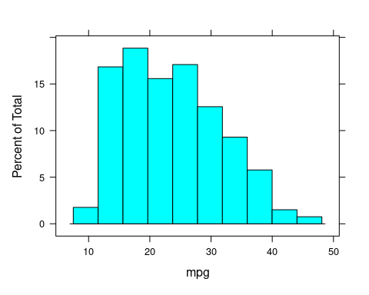

**INFERENCE**

* As mpg plotted in histogram the mean is high than median so it right skewed
* *The MGP falls on **Poisson distribution and maximum number of MPG is in between 10 and 30**

summary(df$displacement)

## Min. 1st Qu. Median Mean 3rd Qu. Max.   
## 68.0 104.2 148.5 193.4 262.0 455.0

histogram(~displacement,data=df)

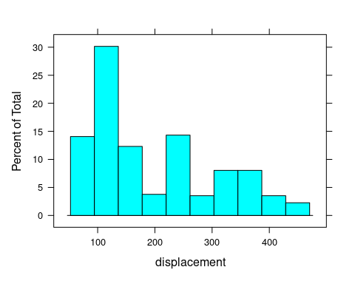

**INFERENCE**

* As displacement plotted in histogram the mean is high than median so it right skewed
* The **maximum number of** displacement **is in between 100 and 150**

summary(df$weight)

## Min. 1st Qu. Median Mean 3rd Qu. Max.   
## 1613 2224 2804 2970 3608 5140

histogram(~weight,data=df)

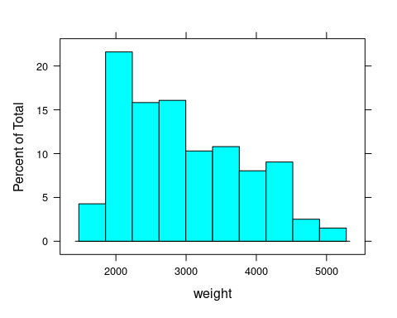

**INFERENCE**

* As weight plotted in histogram the mean is high than median so it right skewed
* The Weight falls on **Poisson distribution and maximum number of** Weight **is in between 2000 and 3000**

summary(df$horsepower)

## Min. 1st Qu. Median Mean 3rd Qu. Max.   
## 46.0 75.0 92.0 103.6 125.0 230.0

histogram(~horsepower,data=df)

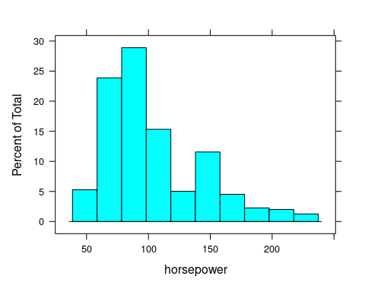

**INFERENCE**

* As horsepower plotted in histogram the mean is high than median so it right skewed
* The **maximum number of** horsepower **is in between 50 and 100**

histogram(~weight|origin,data=df)

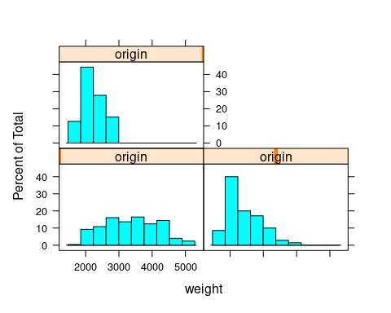

**INFERENCE**

* The 2 origin has all most equal distribution of weight and other two origin has low weight car

histogram(~mpg|origin,data=df)

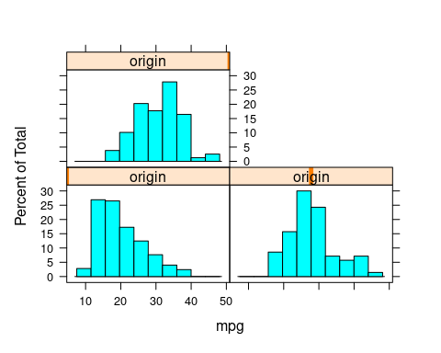

**INFERENCE**

* The 1 and 3 origin has best MPG than 1 origin mpg

histogram(~horsepower|origin,data=df)

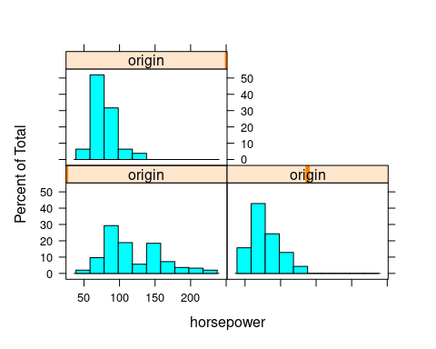

**INFERENCE**

* Origin 1 and 3 has horsepower range between 10 to 150
* Origin 2 has horsepower range between 10 to 250

histogram(~displacement|origin,data=df)

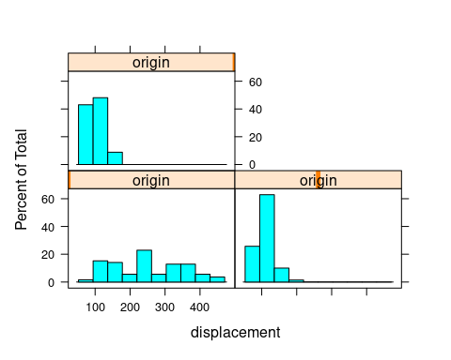

**INFERENCE**

* The displacement is similar to horsepower.

#scatterplots  
xyplot(mpg~weight,data = df,main = "Scatterplot Matrix")

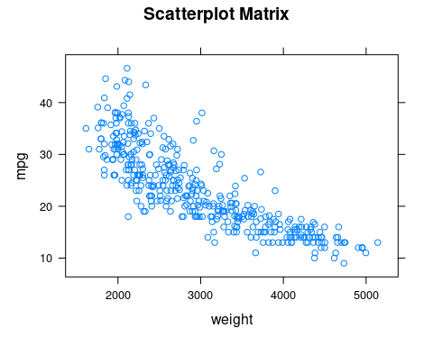

**INFERENCE**

* It is high correlation
* High the weight of the car. Lower the MPG(mile per gallon)
* At the weight 2000 the MPG is high as 45

xyplot(mpg~displacement,data = df,main = "Scatterplot Matrix")

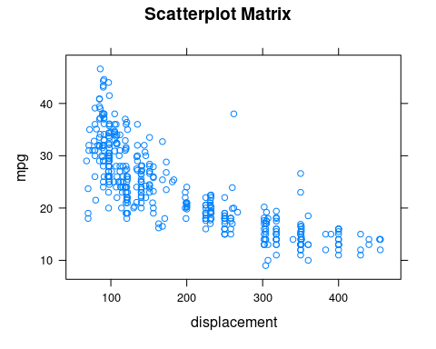

**INFERENCE**

* This scatter plot is high correlation
* High the MPG lower the displacement

xyplot(mpg~acceleration,data = df,main = "Scatterplot Matrix")

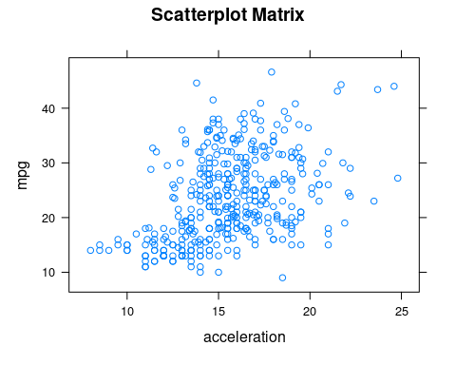

**INFERENCE**

* This scatter plot is Spearman's rank correlation
* High the MPG(mile per gallon) high the acceleration

#Baxplot   
boxplot(mpg~model_year,data=df,xlab = "model_year",ylab = "Miles per gallon",main = "myg based on model_year")

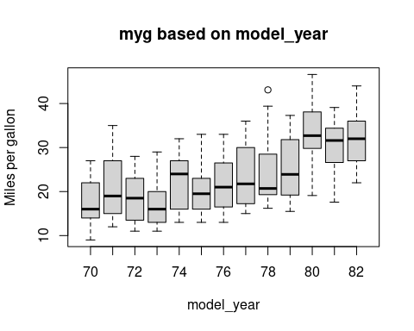

**INFERENCE**

* 80’s Model_year car has the highest mean and median value
* 73’s Model_year car has the lowest mean and median value

**Problem:**

Automobile company needed to analysis the car and find the reason for decreasing in **MPG** (Miles per Gallon) of car and think that affect it.

For analysis the above issue, attribute like MPG, Cylinders, Displacement, Horsepower, Weight, Acceleration, Model_year, Origin, and Car_name

**Assumption:**

The basic idea of analyzing the Auto mpg dataset is to get a fair idea about the factors affecting the aggregate fuel consumption of each car.

Fuel consumption of car is affected by various factors such as Model year, Number of Cylinders present, displacement, Weight and Acceleration of the car.

We need to find which factors mostly affect the Fuel consumption of a car in order to improve the mpg value.

Hence build a model to predict the mpg value of each car.

**Features on data set:**

**Cylinders:** contains the number of cylinders present in the car

**Displacement:** contains the Displacement of the car

**Horsepower:** contains the Horsepower of the car

**Weight:** contains the weight of the car

**Acceleration:** contains the Acceleration of the car

**Model_year:** contains the model year of the car

**Origin:** Cars of different variants of different models of various Car manufacturing companies from origin countries such as USA, Japan and Europe.

**Car_name:** contains the name of the car (Brand-Model-Variant)

Target Variable

**Mpg:** contains the fuel consumption value (in Miles per Gallon) for car

Insight:

* Car's Fuel consumption (in mpg) is mostly affected by weight and Displacement of the car.
* Less the weight of the car more the mpg and heavy the car less mpg
* The displacement will happened accident to horsepower
* 80’s Model_year car has the higher variant of mpg out of all other Model_year and they also have the lowest number of cylinders present in the car
* Higher the displacement higher the horsepower